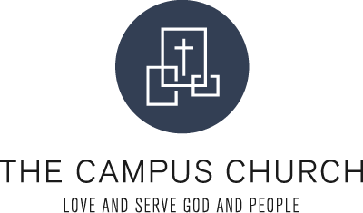

**Campus Group Discussion Resource**

***Essentials – Eliminating Hurry***

For today’s session I want to expose you to an up and coming contemplative pastor. His name is John Mark Comer. This is an excellent talk on slowing down and eliminating hurry from our lives. Please watch the video and discuss key thoughts that impacted you.

Here is the link for this video

<https://www.youtube.com/watch?v=zdWsptsZkAI>

Here is how John Mark describes himself (https://johnmarkcomer.com/#about-)

## About John Mark Comer

I’m a teacher and writer from Topanga Canyon in LA.

For nearly two decades, I was the founding pastor at [**Bridgetown Church**](https://bridgetown.church/) in Portland, Oregon. We spent many years working out discipleship to Jesus in the post-Christian West, and organized our community around a simple idea: practicing the Way of Jesus together.

In 2021, after leading a five-year initiative around spiritual formation we called “[**Practicing the Way**](https://www.practicingtheway.org/),” I stepped away from my role to create simple, beautiful formation resources for church communities around the world.

Today, I’m developing new practices, courses, and podcasts for Practicing the Way and serving as a teacher in residence at [**Vintage Church LA**](https://www.vintagechurchla.com/) with my wife T and our three kids.

I’m also the New York Times bestselling author of seven books, including my newest manifesto: Practicing the Way, the bestselling [**The Ruthless Elimination of Hurry**](https://www.amazon.com/Ruthless-Elimination-Hurry-Emotionally-Spiritually/dp/0525653090), and [**Live No Lies**](https://www.amazon.com/Live-No-Lies-Recognize-Sabotage/dp/0525653120/ref=pd_lpo_sccl_2/144-6988791-9251646?pd_rd_w=n6BES&content-id=amzn1.sym.116f529c-aa4d-4763-b2b6-4d614ec7dc00&pf_rd_p=116f529c-aa4d-4763-b2b6-4d614ec7dc00&pf_rd_r=7F0FM6F7EZG3B3S0VWDA&pd_rd_wg=3lho2&pd_rd_r=83457cbc-4586-4d49-8578-a233f88404da&pd_rd_i=0525653120&psc=1), [**God Has a Name**](https://www.amazon.com/God-Name-John-Mark-Comer/dp/0310344204/ref=sr_1_1?crid=1P9UPBA4OI1AY&keywords=god+has+a+name&qid=1694056320&s=books&sprefix=god+has+a+%2Cstripbooks%2C898&sr=1-1), and Garden City.

I hold a master’s degree in Biblical and Theological Studies from [**Western Seminary**](https://www.westernseminary.edu/), but these days you’ll find me out walking the oak groves of the Santa Monica mountains working on my next project.